镇江市2017—2018学年第一学期期末考试八年级英语试卷
（满分120分；考试时间100分钟） 2018年1月
- 听力（共20小题，每小题1分，共20分）
第一部分 听对话回答1-10题，每段对话听两遍。
1.What’s the girl’s favourite animal?
A. | B. | C.
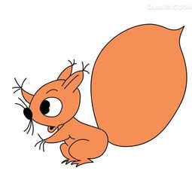 | 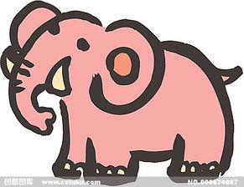 | 
2.What are they talking about?
A. | B. | C.
 |  | 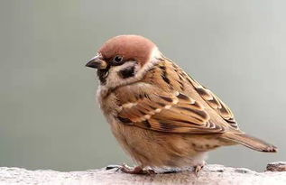
3.What’s the weather like today?
A. | B. | C.
 | 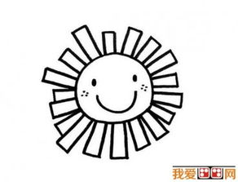 | 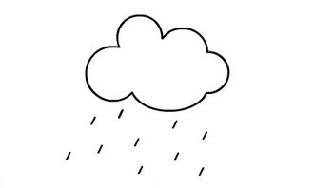
4.What has happened?
A. | B. | C.
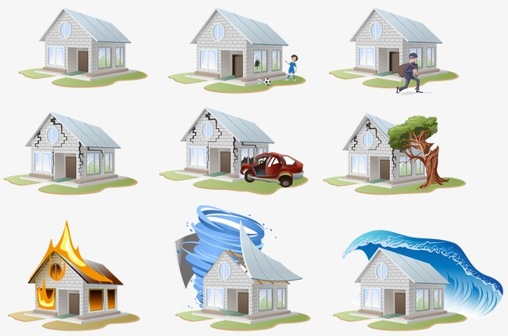
5. What are they going to do?
A. Make a snowman. B. Have a snowball fight. C. Enjoy the snow.
6. How many square kilometres does the nature reserve cover?
A. 3,400. B. 3,004. C. 3,040.
7. What does the man have in his hand?
A. A tiger tail. B. A tiger bone. C. A wolf bone.
8. How does the man go to Xi’an?
A. By train. B. By bus. C. By plane.
9. What does NOT often happen in America?
- Snowstorms. B. Floods. C.Earthquakes.
10. What’s the temperature of tomorrow?
A. 0 ℃ B. 5 ℃. C. -5 ℃.
第二部分 听对话和短文回答问题，每段材料听两遍。
听第一段材料，回答第11-12小题。
11. What are they going to do?
A. Feed the birds. B. Go birdwatching. C. See a film.
12. Which of the following is NOT true?
A. Both of them are free tomorrow.
B. The man thinks it’s easier to be hungry when people are out.
C. The woman agrees to take some water and snacks with them.
听第二段材料，回答第13-15小题，完成信息记录表。
Kate’s different ways to enjoy four seasons
Spring | - Go to the park, sit 13. ______chatting with her classmates and listen to music.
Summer | - Swim in the river in front of her home.
Autumn | - Go 14. ______with her cousin Jane.
Winter | - Have snowball fights and make snowmen with her 15. ______.
13. A. on the bench B. on the playground C. on the grass
14. A. shopping B. hiking C. boating
15.A. friends B. sisters C. brothers
听第三段材料，回答第16-20小题。
16. How many bears are there in the family?
A. One. B. Two. C. Three.
17. What’s the bears’ house like?
A. Small but beautiful. B. Small but warm. C. Big and warm.
18. When did they like to pick strawberries?
A. On Saturday. B. On Sunday. C. On Tuesday.
19. Why did a pig go into the bears’ house?
- Because he was hungry.
- Because he was afraid of the farmer.
- Because he wanted to find a comfortable place to stay.
20. What do you think of the bear family?
A. Honest. B. Generous. C. Terrible.

二、单项选择（共15题：每小题1分，满分15分）
21. – Jane, can I have ______eraser? Oh, I mean a rubber.
– OK, here you are.
- / B. an C. a D. the
22. Our foreign teachers will try to visit the Jianshan Park by ______next Saturday.
A. they B. their C.them D. themselves
23. – Is your sister coming to Zhenjiang during the Spring Festival?
–I’m not sure. She ______not come.
A. must B. can C. may D. should
24. Yesterday I tried to ______some lights alone, but I asked for help in the end.
A. put in B. put on C. put out D. put up
25. – How do you like the film Coco?
–Oh, really exciting. I have never enjoyed a ______one before.
A. worst B. best C. worse D. better
26. – When did the Shining Shopping Mall have a power cut?
– At 9 pm last night, while I ______a film with my brother at the cinema.
A. have seen B. were seeing C. was seeing D. saw
27. – Do you like reading newspapers?
– Yes, it always ______the newest news for me.
- gives B. provides C. offers D. shows

28. – Betty, why have you decided ______a French course.
– Because I will go to France for a holiday next year.
- take B. taken C. taking D. to take
29. All the following sentences use the structure “S+V+P” EXCEPT ______.
A. She likes flowers. B. He keeps fit.
C. That music sounds great. D. Leaves turn brown.
30. Next week, there will be a heavy snow and the temperature will fall ______zero.
A. among B. above C. below D. under
31. “Blow” with the sound // rhymes (押韵) with ______.
A. cow B. how C. now D. grow
32. – Lucy, if you want to join the Painting Society, you should fill in the ______form.
– Thanks for your advice！
A.application B.instruction C.competition D.action
33. – Mum, what’s wrong with Dad?
– ______serious. He has just got a cold.
A. Something B. Everything C. Anything D. Nothing
34. My father is busy. Every year, he only has ______10 days off while we have 30.
A. at first B. at most C. at least D. at last
35. – I'm afraid I can't go to your birthday party, Tom.
– ______! But why?
A. How happy B. What a pity C. How lucky D.What nice news
三、完形填空（共10小题；每小题1分，满分10分）
Ordering food online has become part of college life when doing it only takes a few minutes. However, a university in Southwest China is trying to stop 36 doing it.
The ban(禁令) not only made students unhappy, but also the internet users. Some said that the ban made the 37 full of people. There are not enough seats in it, so students have to stand up or squat(蹲) when they eat. The 38 dining hall also means that students have to spend more time eating. If students can order online, they can have more time to 39 at noon so that they will be energetic in the afternoon. Some even said 40 that the dining hall only provides a few dishes and almost all of them taste bad.
In fact, Guangxi University of Foreign Languages is not the 41 one to do so. Beijing Language and Culture University and some other universities have already done that. A teacher from Guangxi University of Foreign Languages said that schools stopped students ordering food online 42 the food from outside is not safe for students. Moreover, ordering too much food led to a serious 43 problem, as there were often many used food boxes left in the school campus after students 44 meals.
However, in the eyes of Liu Junhai, a teacher at Renmin University of China, universities themselves should take action. “If schools make their dining halls better, their students will soon 45 . For example, they can provide more tasty dishes.”
36. | A. | students | B. | teachers | C. | parents | D. | friends
37. | A. | classroom building | B. | dining hall | C. | swimming pool | D. | school library
38. | A. | clean | B. | busy | C. | modern | D. | empty
39. | A. | play | B. | eat | C. | rest | D. | think
40. | A. | happily | B. | angrily | C. | seriously | D. | hopefully
41. | A. | earliest | B. | worst | C. | slowest | D. | best
42. | A. | but | B. | so | C. | and | D. | because
43. | A. | noise | B. | air | C. | water | D. | rubbish
44. | A. | finished | B. | prepared | C. | started | D. | cooked
45. | A. | go away | B. | come back | C. | stand up | D. | look forward
四、阅读理解（共10小题；每小题2分，满分20分）
A
An earthquake happened inside the Jiuzhaigou National Park. The exact information is not enough now, but we can be sure there have been a lot of falling stones and landslides. More information will arrive over the coming days.
You can go out of Jiuzhaigou from the Eastern Road in Pingwu and right now most of tourists have been evacuated(被转移). Jiuzhaigou National Park is now closed to visitors until further information is offered to make sure everything is safe and OK for everyone.
If you have planned to visit in the next few days, please make a change so that the roads are not busy for the cars and buses to carry the things people need in Jiuzhaigou. Please keep in touch with your local travel agency(旅行社) for further information.
If you have already bought the tickets to Jiuzhaigou National Park, you can get your money back by returning the tickets.
For more information you can follow www.facebook.com/Jiuzhai or on Weibo at http://weibo.com/jiuzhaigou
46. The following disasters happened in Jiuzhaigou National Park EXCEPT ______.
A. an earthquake B. falling stones C. landslides D. a snowstorm
47. What right information can people get from the passage?
A. Jiuzhaigou National Park is now closed to visitors.
B. Visitors can go out of Jiuzhaigou from the Western Road in Pingwu.
C. People should use a different road to make the roads to Jiuzhaigou busy.
D. If tourists buy the tickets to Jiuzhaigou National Park, they can’t return tickets.
48. The writer writes this passage in order to tell people ______.
A. Jiuzhaigou National Park is very beautiful
B. Jiuzhaigou National Park is popular among visitors
C. it’s not the right time to visit Jiuzhaigou right now
D. Jiuzhaigou National Park is open to visitors for free
B
Giant panda Pengpeng died last Sunday night, the China Research(研究) Center announced(宣布)on Thursday. He had been fighting illness for 11 days before he died, Chinanews.com reported.
Workers in the center found there was something wrong with Pengpeng’s head and later Pengpeng became worse at the end of November. Several symptoms(若干症状) appeared since then and Pengpeng did not wake up again after 11 days' treatment(治疗).
Pengpeng, a male(雄性的), was born on Sept 5, 1999. He started to lose his eyesight after getting an eye illness, so he had to live alone in a different place in the center.
Pengpeng was popular on the Internet because his keeper Tangtang put many photos on the internet when he was alive. Many "fans" were sad and sent well-wishes after hearing about the panda’s death.
“I still remember him slowly eating a steamed corn bun(蒸玉米) with Tangtang sitting beside him. That was such a quiet and beautiful picture. Wish him happy with no illness on ‘Panda Earth’,” said one of the panda-lovers.
Tangtang wrote an article to remember Pengpeng, and hoped Pengpeng’s smile can continue to cheer people up, even though he cannot see them again.
The China Research Center have invited more specialists(专家) to take part in the study of the causes of Pengpeng’s death. They all hope in the future, they can help pandas live longer and better .

49. Which of the following is TRUE according to the passage?
A. Pengpeng died about 11 years ago.
B. There was nothing wrong with Pengpeng’s eyes.
C. The causes of Pengpeng’s death were still not clear enough.
D. Pengpeng had to live alone because there was something wrong with his head.
50. What did Tangtang NOT do for Pengpeng?
A. Feed Pengpeng.
B. Make Pengpeng popular on the Internet.
C. Write an article to remember Pengpeng.
D. Invite more specialists to study what made Pengpeng die.
51. What can we infer(推断) from the passage?
A. Male pandas are easy to die.
B. Tangtang didn’t look after Pengpeng very well.
C. Maybe Pengpeng’s smile cheered someone up when he was alive.
D. The China Research Center have already known how to make pandas live longer.
C
Padding ton 2, the second Paddington film has had a successful weekend since it arrived in Chinese theaters on Friday.
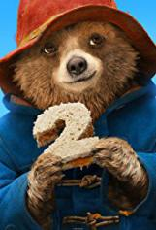
Paddington Bear first appeared（登场） on 13 October 1958 in the children's book A Bear Called Paddington, and then kept on his stories in more than one hundred and fifty books by English writer Michael Bond and other artists. The friendly bear from Peru(秘鲁)—with his old hat, a coat in English style and love of orange jam—has become one of the most famous bears in Britain. Paddington books have been changed into 30 languages across 70 countries and sold more than 30 million copies(册，本) around the world.
Paddington is always polite – calling people "Mr", "Mrs" and "Miss", seldom by first names – and kind, though he often looks angrily at those who do bad things. He has an endless ability to get into trouble, but he also tries so hard to get things right. The (human) Brown family found him in Paddington Station, London, and then adopted him. They kindly provide him with food and shelter. Also, the Brown family gives his full name as "Paddington Brown".
54 . To celebrate the first Paddington Bear film, from 4 November until 30 December 2014, people put 50 Paddington statues(雕像) around London to show their love and happiness. The statues were created by artists, designers and superstars.
If you didn’t have the chance to see those lively statues yourself, why not go to cinema to enjoy this lovely bear in Paddington 2?
52. Which of the following is NOT true according to the passage?
A. The Paddington bear was friendly and polite.
B. Paddington Bear doesn’t like those who do bad things.
C. To celebrate the second Paddington Bear film, 50 statues were put in Peru.
D. When Paddington sees Jack Brown, he will call him Mr Brown politely.
53. The underlined word "adopted" in Paragraph 3 means ______.
A. changed B. raised C. sold D. threw
54. Which of the following can be the first sentence in Paragraph 4？
A. Paddington Bear hates to play by himself.
B. Paddington Bear loves travelling everywhere.
C. Paddington Bear is kind and friendly.
D. Paddington Bear is popular among different people in Britain.
55. What's the best title of the passage?
A. Save the poor Paddington Bear!
B. Let’s read a good book named Paddington Bear!
C. Enjoy the Statues of Paddington Bear in London!
D. Don’ t miss the great film, Paddington 2!
五、词汇运用(共15小题；每小题1分，满分15分)
A.根据括号内所给单词的正确形式填空，每空一词。
56. It’s dangerous to drive on a _______(snow) day.
57. A man without worries can always fall asleep as _______(easy)as a baby does.
58. When Jack meets problems, he often tells _______(he)not to give up.
59. It is _______(use)to talk with Tom because he doesn’t like accepting others’ advice.
60. – Whose books are these? – Maybe those _______(speak). I saw them hurry to leave.
61. Singapore is famous for making laws to prevent people _______(drop) litter everywhere.
62.To have bigger and better fish, most _______(fish) will stop fishing some time every year.
63. More and more people like to buy _______(nature)food from farmers because it is healthier.
B.根据句意、汉语提示或音标写出各单词的正确形式，每空一词。
- Taking photos can help people _______(记录) the great moments of lives.
- Lily’s bedroom is always the _______(整洁的) in her home because she often cleans it.
66. When police came and asked about that accident, he _______(描述)it very carefully.
67. Jim only told his secrets to three friends, but _______(没有一个)of them kept it for him.
68. Before you hand in exam papers, please look _______(从头至尾)all your answers again.
69. Too much work and not enough sleep will lead to a _______(头疼)and some other illnesses.
70. The traffic was busy. As a result, My parents missed the _______//of the movie called Fanghua.

六、改写下列句子保持意思不变，每空一词（共5空；每空1分，满分5分）
71. What’s the weather like?
_______is the weather？
- In the end, the noise and shaking ended.
_______, the noise and shaking ended.
- How heavy was the baby panda when she was born?
What was the _______of the baby panda when she was born?
- It’s impolite for people to go out with nothing on.
It’s impolite for people to go out _______clothes.
- The bad weather led to a serious accident yesterday.
The bad weather _______a serious accident yesterday.

七、短文填空（共10空；每空1分，满分10分）
...<adapted from(改编自) Five Children and It>
Psammead(沙漠精灵) looked very unhappy, and Jane said, “Well, I didn’t know that you were a Psammead, but I can feel that you are something wonderful. Please talk more to us.”
The Psammead looked a little h 76 when it heard that, and it said, “Well, you can talk to me. Perhaps I’ll answer you and perhaps I won’t. Now say something.”
At first, the children could not think of a 77 to say, but then Jane asked, “How long have you lived here?”
“Oh, a very long t 78 , about thousands of years,” the Psammead answered.
The children waited, but the Psammead was silent. “Please tell us more,” Jane said.
“Well, all right, then,” the Psammead said. “There were lots of us then. People sent their children out to look for Psammeads, and when they f 79 us, we gave them a wish.”
“What happened to all the Psammeads, then?” Jane asked.
“Well, Most of us died. And I’m not going to tell you anything.”
“Oh, just one m 80 question, please,” said Jane. “Do you give wishes now?”
“You’ve had one,” said the Psammead. “You w 81 to see me just now, and here I am.”
“Oh, please. Just another wish,” Anthea cried.
“Well, all right, but be quick! I’m tired of you!”
It’s usual that people can’t think of a really good wish, in j 82 a second or two. Then, about some time later, Anthea remembered a wish of hers and Jane’s. “I wish b 83 of us become very, very beautiful,” she said.
The girls stood there for a second, and then Anthea turned to speak to Jane, b 84 Jane was not there! Anthea was looking at a stranger— a girl with beautiful red hair and big blue eyes. Suddenly she u 85 they had their wish. The stranger was Jane— now they were beautiful.

八、任务型阅读(共10小题；每小题1分，满分10分)
A
Every time a new year comes, people will set a goal or make a wish to try to make themselves better. They make wishes that they will become slimmer, find a new job, or maybe even take that vacation they've always talked about. But why do we make these wishes ourselves, and where did this tradition come from? Why can this tradition still go on when many people are unable to keep wishes? Well, we can start by blaming(责怪) the old Babylonians(巴比伦人).
Around 4000 years ago in Babylon, people there held the earliest celebration to celebrate the coming of a new year. The Babylonians started different activities after the Spring Equinox(春分). People used these festivals to celebrate the rebirth of the sun god (太阳神)Marduk, and the Babylonians also made wishes in order to make their gods happy. They felt this would help them start the New Year better.
To this day, the tradition of the old Babylonians go on around the world. Google made a game on the internet in 2003, and in that game people could add their wishes and also see others’ in real time. Many people took part in this game. However, only eight percent of people could keep on making their wishes come true.
根据短文内容，完成以下内容，每空一词。
People will do different things to celebrate the New Year. To make wishes is one of the traditions. The Babylonians held celebrations to celebrate the New Year 86 than the other countries. During the festivals, they not only celebrated the rebirth of the sun gold but also tried to make gods happy. Now, at the start of the New Year, we also make wishes that we can become slimmer, find a new job or spend 87 we are looking forward to. However, most of us 88 to keep our wishes. Google made an online game in 2003. Many people 89 in the game and added their wishes. In the end, 90 percent of people couldn’t make their wishes come true.
B
As more and more people begin to read online, do we still need libraries now ? Reporter Ian Clark has the answer. “Libraries are still important– people still find it greater and easier to use them.
According to him, not everyone has enough money to buy a smart phone, or a computer, and not everyone knows how to search the internet, but libraries can offer people the same chance to get what they want to know about. And sometimes the information online is not correct. It will take you a lot of time to find what you really need. Libraries are more reliable(可靠的). Moreover, we still need a kind of place that a library provides. In a library, it’s easy to get lost in reading and working and it’s also less possible for us to stop to do something else.
So working in a library is quite helpful. We usually call this kind of place “third places”. There are some other “third places” like coffee shops. They can also make you relax completely. And you see no sellers or advertisements in the library. If you spend all your time on computers, your eyes will get tired.
You should go to the library to find out the true, meaningful, and exact information about things. The world still needs libraries and it doesn't matter if you don't think so because most people do.
根据短文内容，完成表格，每空一词。
Reading in libraries is still important.
Reasons | - 91 is able to use libraries to get information, including the poor and the old.
Reasons | - You may get some 92 information from the Internet while the information from libraries is more reliable.
Reasons | - Libraries can offer a kind of “third places” to 93 people work more attentively(专注地). People can feel more relaxed there.
Reasons | - No one 94 things or advertises for something when you read in libraries.
Reasons | - It’s healthier to read in libraries than on the Internet.
Conclusion | - Not all people read online 95 of reading in libraries because people still like using libraries to find out the true, meaningful and exact information themselves.

九、书面表达 （共1小题；满分15分）
假如你叫Jack，寒假期间，学校将组织喜欢野生动物的同学一同前往Moonlight Town进行旅游学习。你需要根据表格内容写一封信给校长，申请参加。
姓名 | Jack | 爱好 | 摄影，研究野生动物 | 特点 | 强壮，幽默，乐于助人
申请原因 | 1. 去年寒假只是呆在家里写作业，或者走亲戚。感觉很无聊。  2. 如果能参加这次旅游，会非常开心；可以为大家做很多事情：  - 擅长拍照；  - ……（另外列举至少两条能够做的事情。）
联系方式 | 电子邮件:88222222@qq.com  电话：13388888888
注意：1. 所写内容必须包括表格中所提供的信息，并适当发挥；
2. 文章90词左右，开头结尾已给出，不计入总词数；
3. 语意通顺，意思连贯，条理清楚，书写规范；
4. 文中不得出现真实的姓名、校名等信息。
Dear Headteacher,
I would like to join the school trip to watch wildlife in Moonlight Town this winter holiday.

_____________________________________________________________________________
_____________________________________________________________________________
_____________________________________________________________________________
_____________________________________________________________________________
_____________________________________________________________________________

Yours sincerely,

Jack

